**Guide of Installation of Lyrics Scraping Program**

The module that I uploaded to the repository have the following structure:

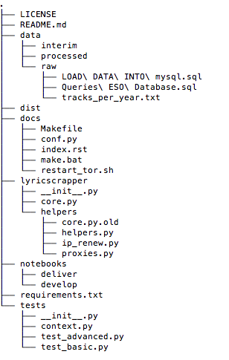

To use it please carefully follow these instructions:

1. Clone the repository to your Mac
2. Install these libraries into your Python 3.6 with pip install:
   * re
   * urllib
   * bs4
   * user_agent
   * pymysql
   * random
   * time
   * cryptography
3. Install **tor** in your mac with this command: **brew install tor**
4. Execute: sudo brew services start tor
5. Install **privoxy** in your mac with this command: **brew install privoxy**
6. Execute: sudo brew services start privoxy
7. In the folder **/usr/local/etc/privoxy** edit the “**config”** file and uncomment the line that contains something like **forward-socks5t** in order to look like this (the dot at the end is important, don’t deleted):

**forward-socks5t / 127.0.0.1:9050 .**

1. After that just restar the privoxy service by executing: **brew services restart privoxy**
2. Use the command crontab –e to create a cron job with the following line:

**\*/1 * * * * /georgetown/ds/Music-Mood/docs/restart_tor.sh > /usr/local/etc/musicmood_restart.log**

1. Take into account that the previous script uses the folder **/georgetown/ds/Music-Mood/docs/** please **change it to the folder where you clone the repository**
2. You can verify if the Tor – Privoxy is working by running the file **proxies.py** that is included in the **helpers** folder within **lyricscrapper** module

The idea behind a part of the program is protect your external IPs from being blocked. Therefore, we will use Privoxy as a Proxy server to forward the traffic through the circuits of the Tor network. The cron job is restarting the tor service every minute so a new external IP is used.

1. To use the scrapper, change the value of the MAX_LIMIT and the MIN_LIMIT and the run the core.py file like: **python core.py**

The program is already connecting to the AWS Server configured by Ivan, and I’ve migrated the table that my program use. The current efficiency is 30%, any ideas or changes are welcome to improve and obtain lyrics from more songs. In the following table I’m proposing the limits for each one of us:

|  |  |  |
| --- | --- | --- |
| **NAME** | **MIN** | **MAX** |
| Ivan Narvaez | 1 | 128895 |
| Katie Sebby | 128896 | 257790 |
| Sebastian Oliva | 257791 | 386685 |
| Marcelo Carrillo | 386686 | 515580 |

1. **Security Update:** for security reasons I’ve decided to implement some sort of protection. Therefore, all the information about the database will be stored on a binary file that you will be able to create with another script I’m going to send you. Moreover, if you just clone the repository and don’t execute the given script it is going to tell you that there is a missing file. This file is going to be a binary file that include and scripted object with the information of the server, the database name the user and the password.